Gas Thermometer
# Source: AI Source: Provided by: [Data Path: Persons Table -> ID Column: 1, Name_En Column: Motasem Essam] -> From: [ChatGPT] on [7/17/2026]
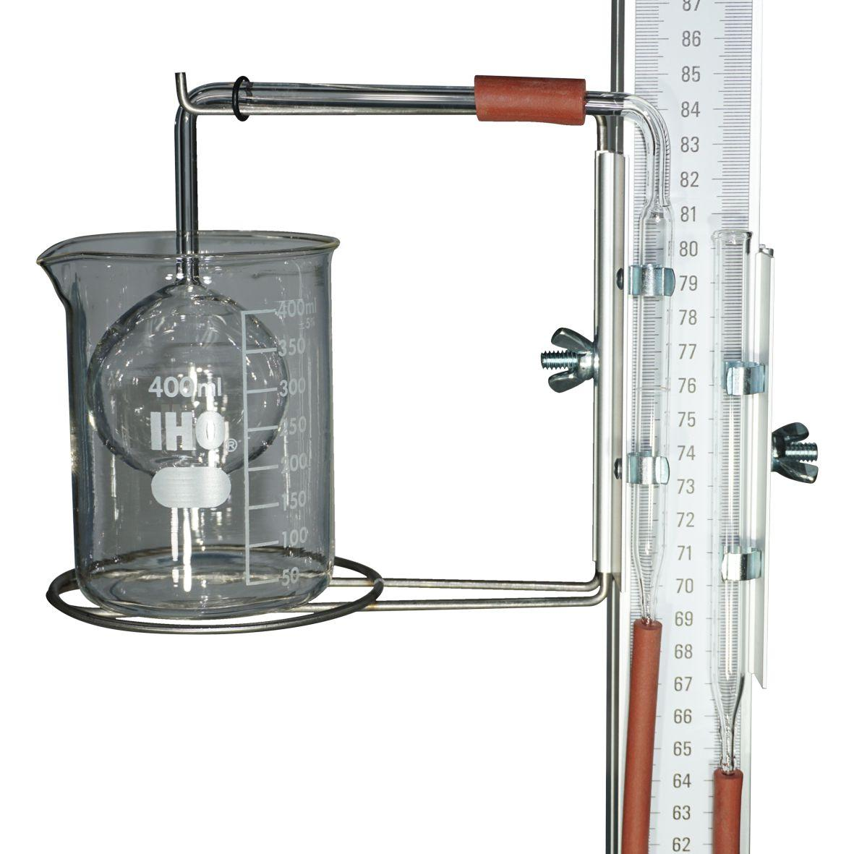
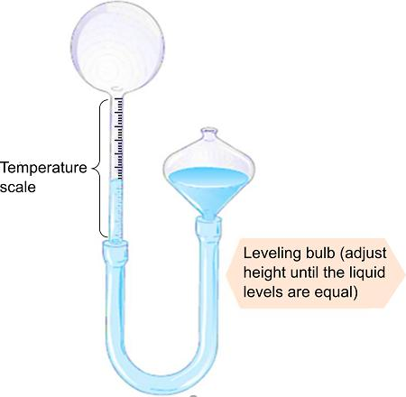
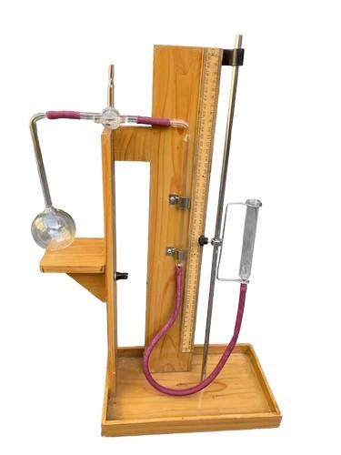
A Gas Thermometer is a highly accurate temperature-measuring instrument that determines temperature by measuring the change in the pressure or volume of a gas. Because the behavior of gases closely follows the gas laws, gas thermometers are considered primary reference instruments and are widely used in metrology laboratories, scientific research, and calibration.

Definition
# Source: AI Source: Provided by: [Data Path: Persons Table -> ID Column: 1, Name_En Column: Motasem Essam] -> From: [ChatGPT] on [7/17/2026]
A Gas Thermometer is an instrument that measures temperature by observing the relationship between the pressure, volume, and temperature of a gas.

Purpose
# Source: AI Source: Provided by: [Data Path: Persons Table -> ID Column: 1, Name_En Column: Motasem Essam] -> From: [ChatGPT] on [7/17/2026]
A gas thermometer is used to:
- Measure temperature with very high accuracy.
- Establish temperature standards.
- Calibrate other thermometers.
- Perform scientific experiments.
- Conduct thermodynamic research.

Principle of Operation
# Source: AI Source: Provided by: [Data Path: Persons Table -> ID Column: 1, Name_En Column: Motasem Essam] -> From: [ChatGPT] on [7/17/2026]
A gas thermometer operates based on the Ideal Gas Law:
$$PV=nRT$$
For a fixed amount of gas:
- Constant-volume gas thermometer: Temperature is proportional to pressure.
- Constant-pressure gas thermometer: Temperature is proportional to volume.
As temperature changes, either the gas pressure or gas volume changes in a predictable manner.

Main Components
# Source: AI Source: Provided by: [Data Path: Persons Table -> ID Column: 1, Name_En Column: Motasem Essam] -> From: [ChatGPT] on [7/17/2026]
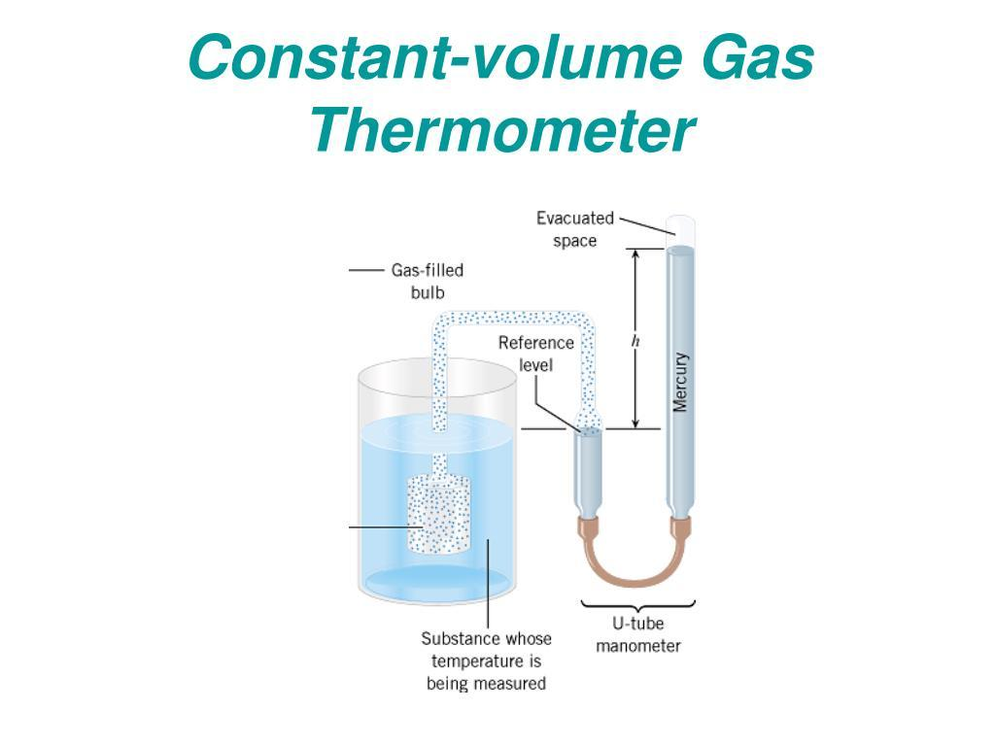
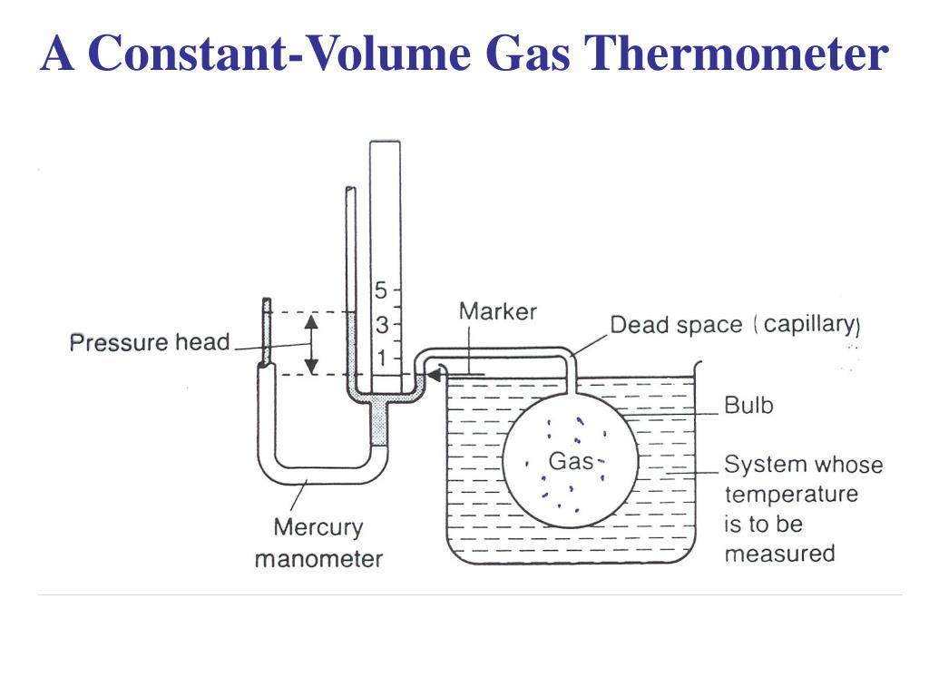
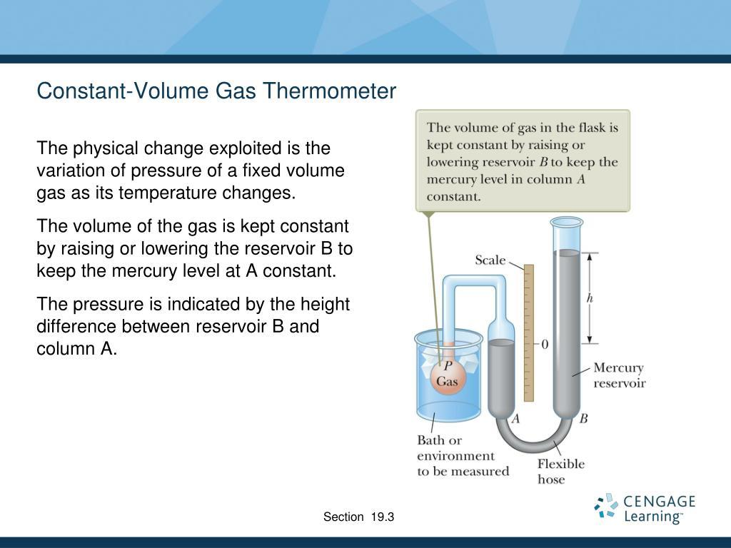
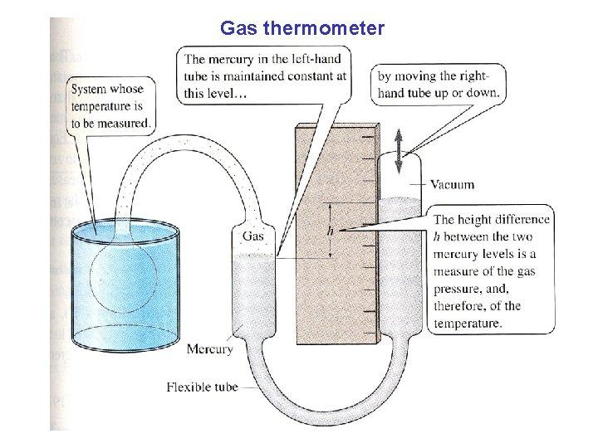
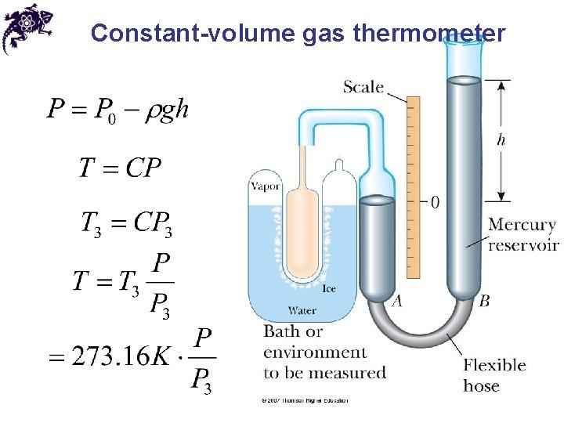
A typical gas thermometer consists of:
- Gas-filled bulb
- Capillary tube
- Pressure or volume measuring system
- Reservoir (some models)
- Scale or digital indicator
- Protective housing

Types of Gas Thermometers

1. Constant-Volume Gas Thermometer
# Source: AI Source: Provided by: [Data Path: Persons Table -> ID Column: 1, Name_En Column: Motasem Essam] -> From: [ChatGPT] on [7/17/2026]

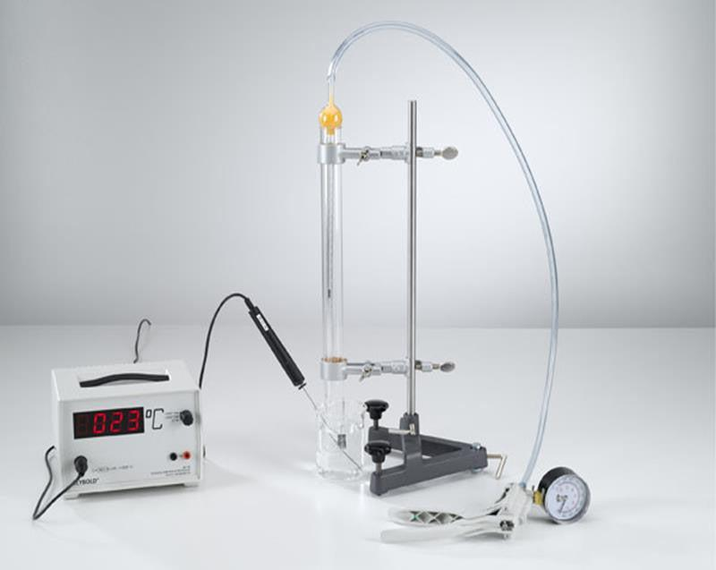
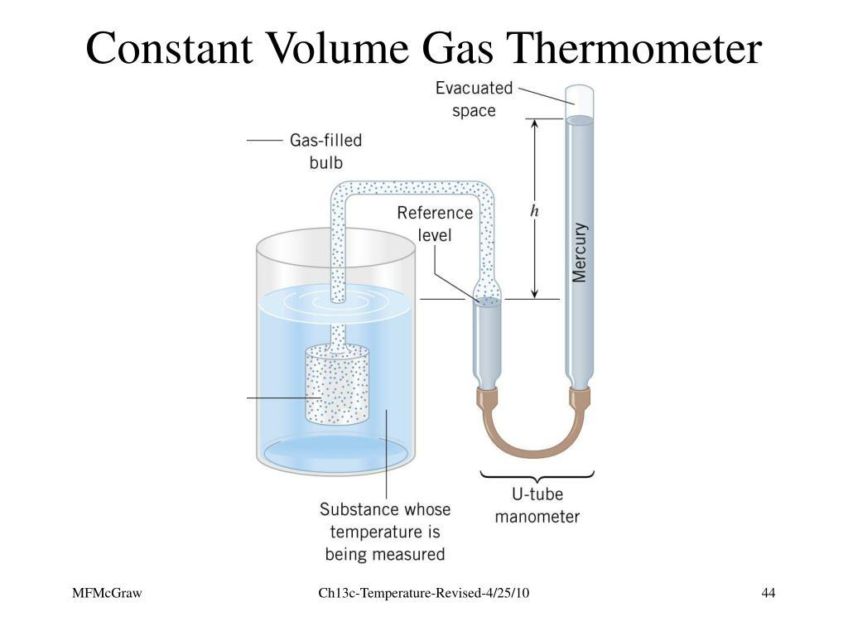
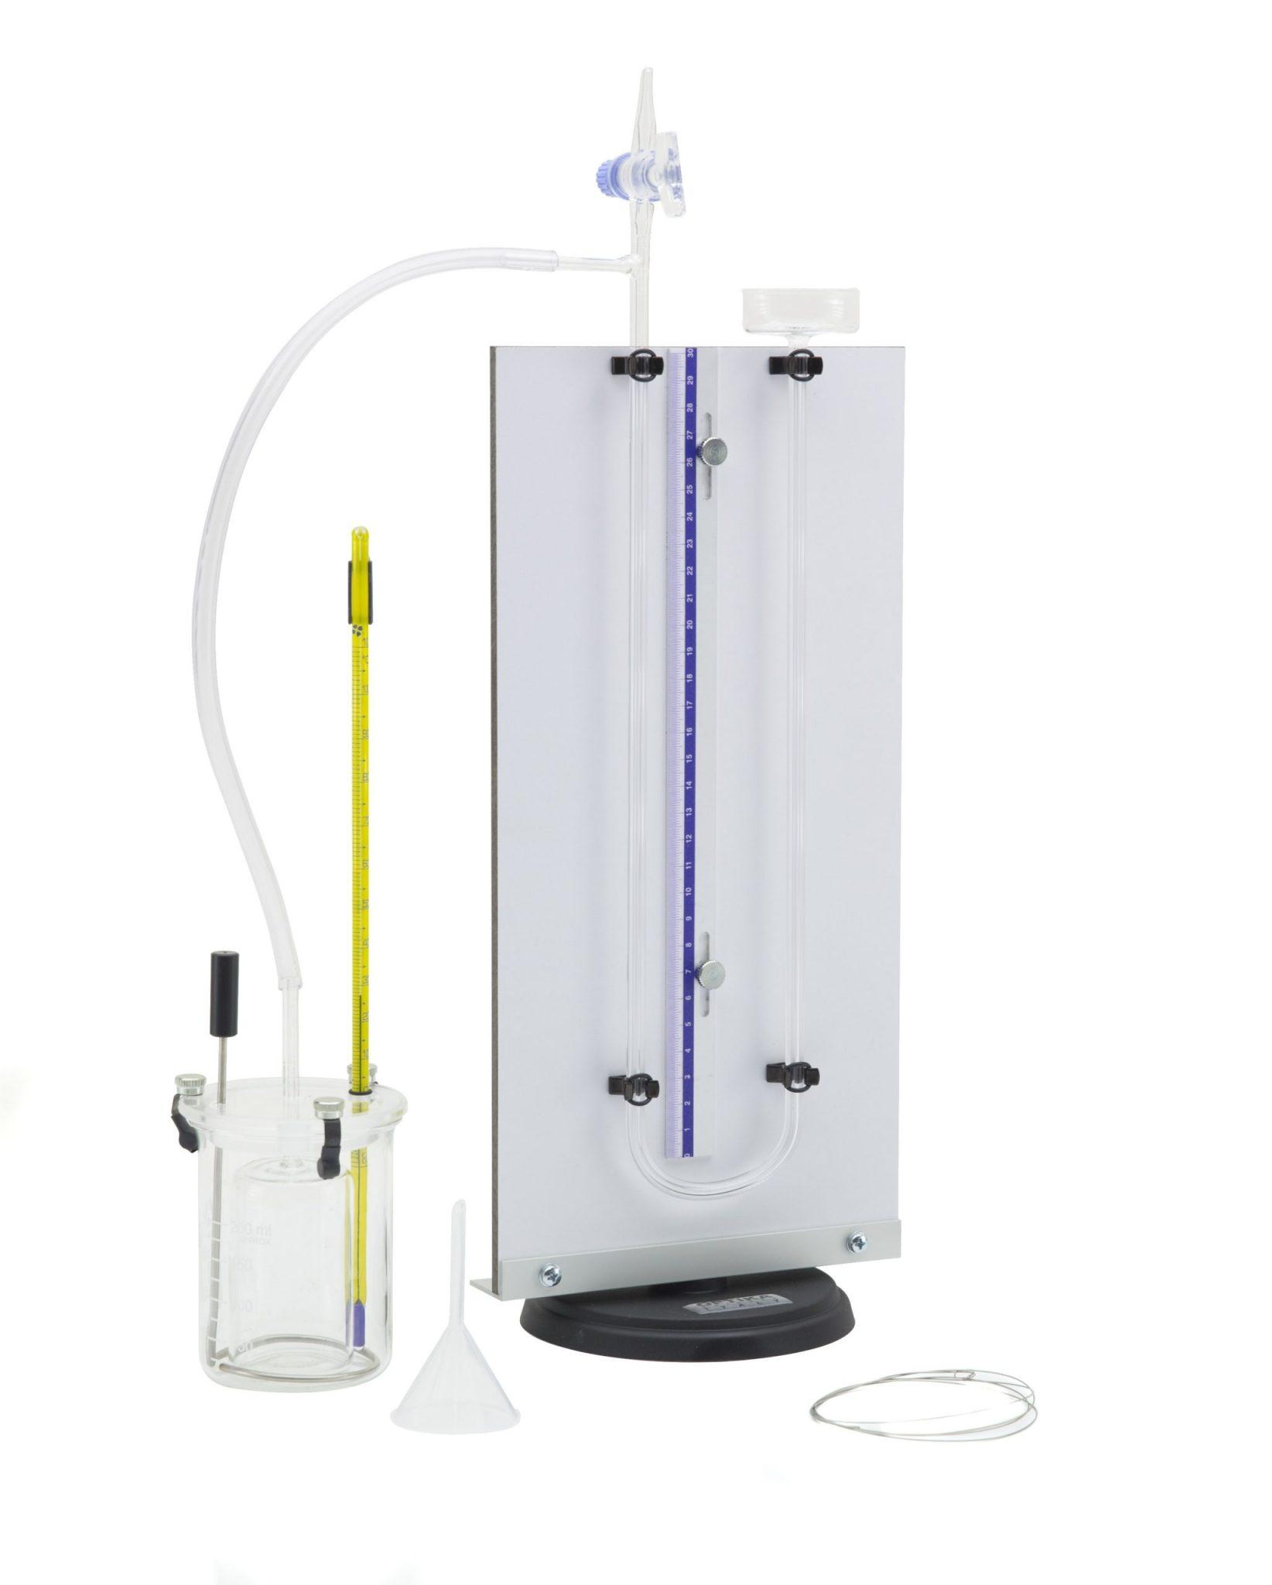
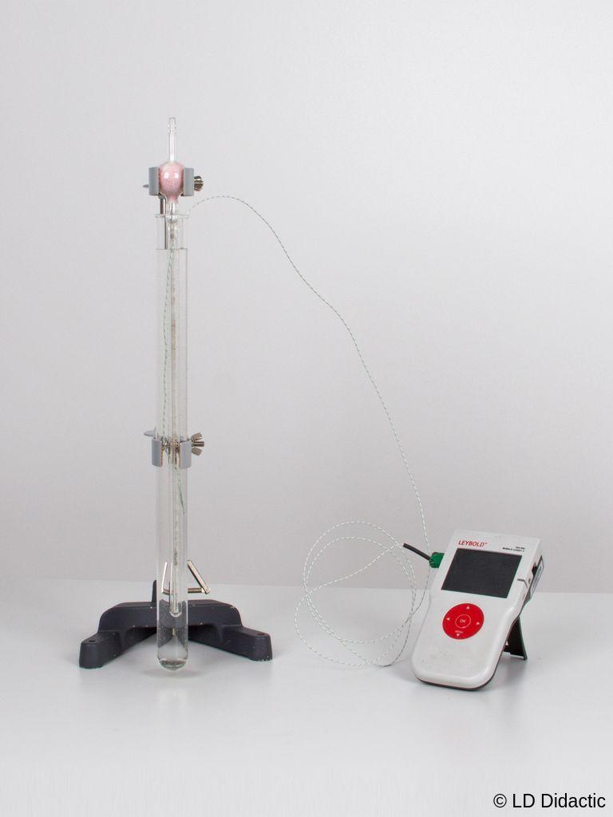
Description
The gas is kept at a constant volume while its pressure changes with temperature. This is the most accurate type and is commonly used as a reference standard.
Applications
- National metrology institutes
- Calibration laboratories
- Scientific research
- Thermodynamic measurements

2. Constant-Pressure Gas Thermometer
# Source: AI Source: Provided by: [Data Path: Persons Table -> ID Column: 1, Name_En Column: Motasem Essam] -> From: [ChatGPT] on [7/17/2026]
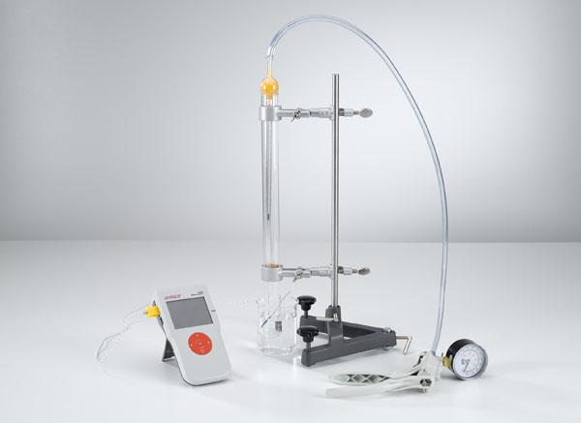
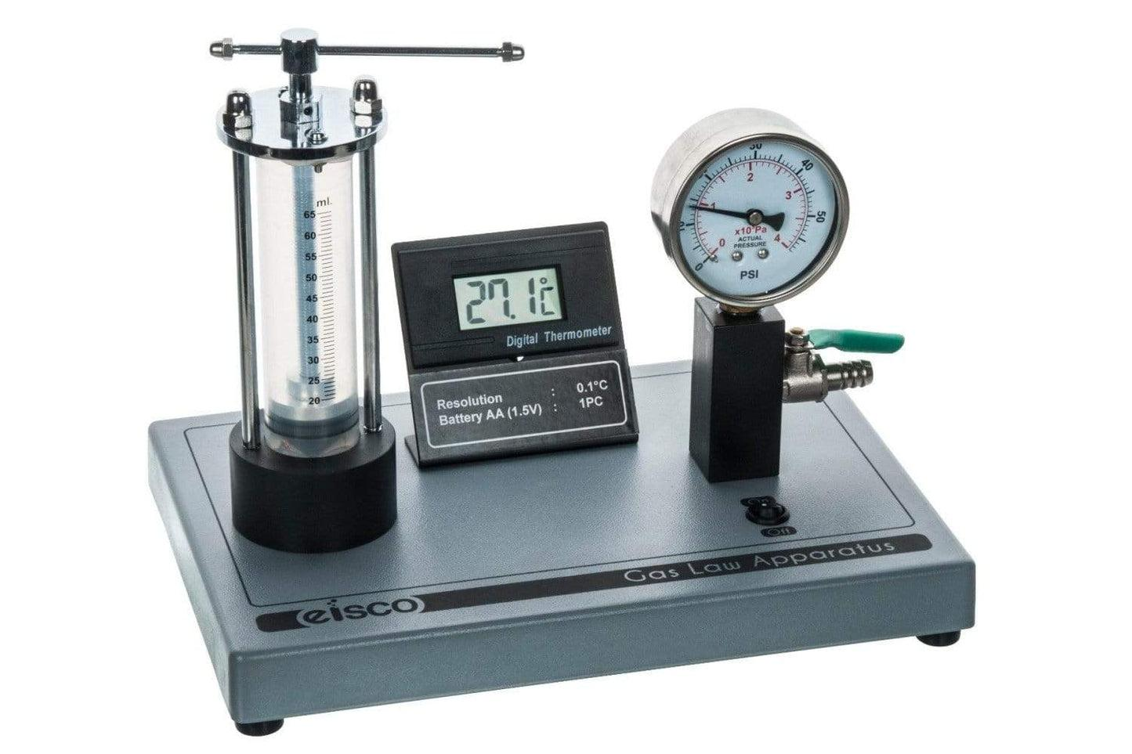
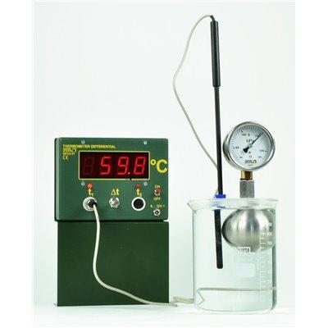
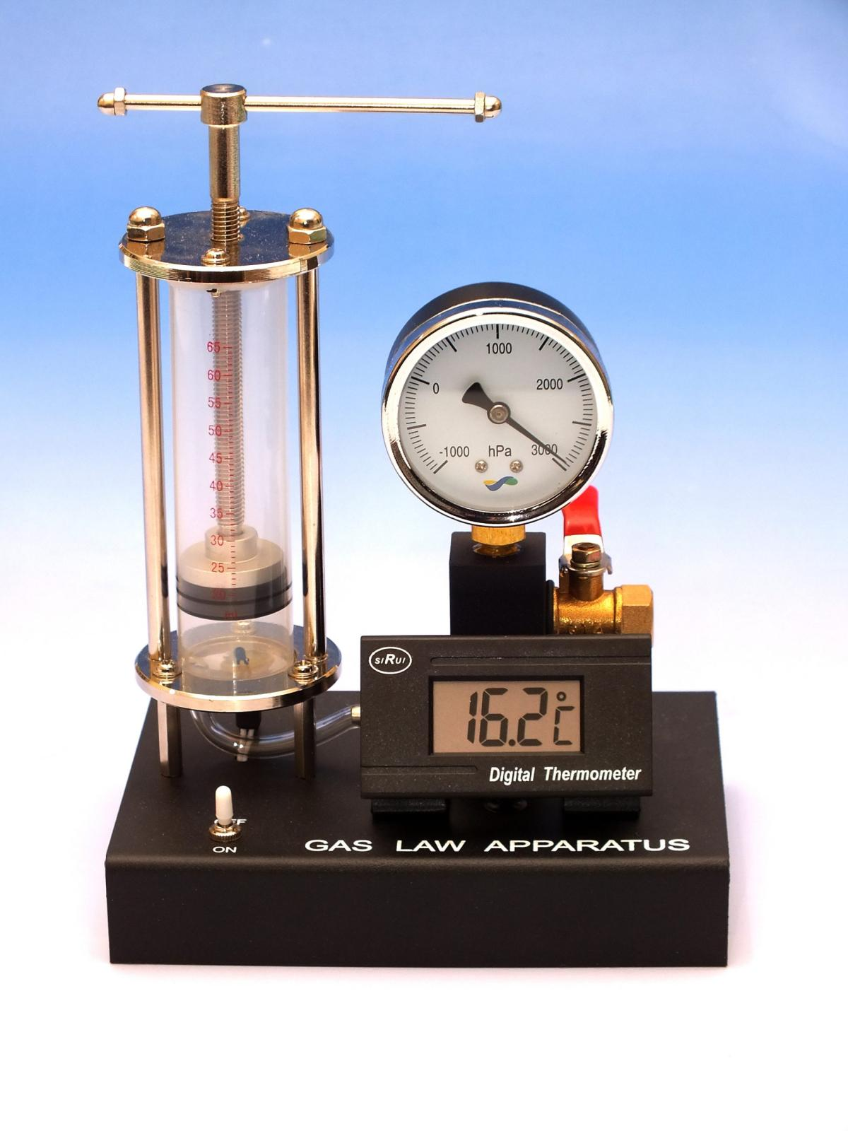
Description
The gas pressure remains constant while the gas volume changes as the temperature varies.
Applications
- Research laboratories
- University teaching laboratories
- Experimental thermodynamics

3. Gas Bulb Thermometer
# Source: AI Source: Provided by: [Data Path: Persons Table -> ID Column: 1, Name_En Column: Motasem Essam] -> From: [ChatGPT] on [7/17/2026]

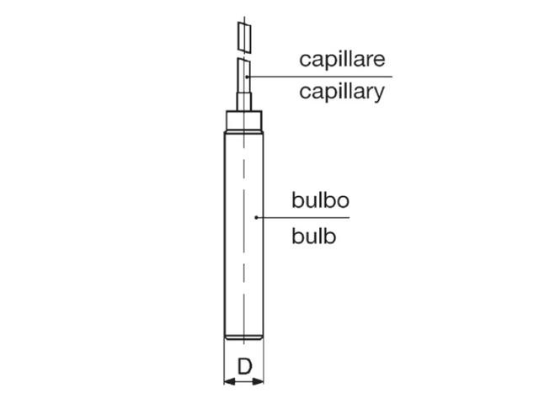
Description
A sealed bulb filled with gas is connected to a pressure-measuring device. Temperature changes are determined from changes in the gas pressure.
Applications
- Industrial laboratories
- Precision temperature calibration
- Scientific experiments

Measuring Units
# Source: AI Source: Provided by: [Data Path: Persons Table -> ID Column: 1, Name_En Column: Motasem Essam] -> From: [ChatGPT] on [7/17/2026]
Gas thermometers commonly display:
- Degree Celsius (°C)
- Kelvin (K)
- Degree Fahrenheit (°F)

Measuring Range
# Source: AI Source: Provided by: [Data Path: Persons Table -> ID Column: 1, Name_En Column: Motasem Essam] -> From: [ChatGPT] on [7/17/2026]
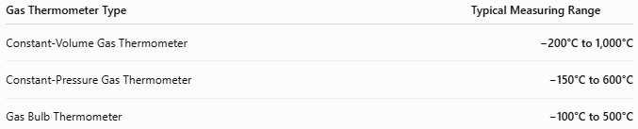
Gas Thermometer Type | Typical Measuring Range
Constant-Volume Gas Thermometer | −200°C to 1,000°C
Constant-Pressure Gas Thermometer | −150°C to 600°C
Gas Bulb Thermometer | −100°C to 500°C

Resolution
# Source: AI Source: Provided by: [Data Path: Persons Table -> ID Column: 1, Name_En Column: Motasem Essam] -> From: [ChatGPT] on [7/17/2026]
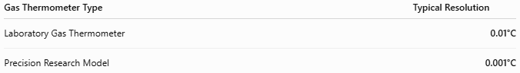
Gas Thermometer Type | Typical Resolution
Laboratory Gas Thermometer | 0.01°C
Precision Research Model | 0.001°C

Accuracy
# Source: AI Source: Provided by: [Data Path: Persons Table -> ID Column: 1, Name_En Column: Motasem Essam] -> From: [ChatGPT] on [7/17/2026]
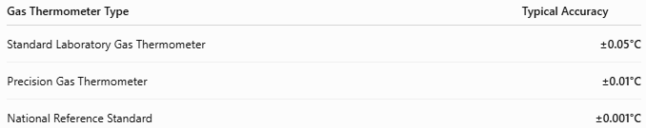
Gas Thermometer Type | Typical Accuracy
Standard Laboratory Gas Thermometer | ±0.05°C
Precision Gas Thermometer | ±0.01°C
National Reference Standard | ±0.001°C
Notes
- Gas thermometers are among the most accurate temperature-measuring instruments available.
- Their measurements closely approximate the thermodynamic temperature scale.
- Accuracy depends on gas purity, pressure stability, calibration, and environmental conditions.

How to Use a Gas Thermometer
# Source: AI Source: Provided by: [Data Path: Persons Table -> ID Column: 1, Name_En Column: Motasem Essam] -> From: [ChatGPT] on [7/17/2026]
- Fill the bulb with the specified gas.
- Place the bulb in the medium whose temperature is to be measured.
- Allow thermal equilibrium to be reached.
- Measure the gas pressure or volume.
- Determine the temperature using the calibrated scale or gas law relationship.

Applications
# Source: AI Source: Provided by: [Data Path: Persons Table -> ID Column: 1, Name_En Column: Motasem Essam] -> From: [ChatGPT] on [7/17/2026]
Gas thermometers are used in:
- Metrology laboratories
- National standards laboratories
- Scientific research
- Thermodynamic studies
- Calibration laboratories
- University laboratories

Advantages
# Source: AI Source: Provided by: [Data Path: Persons Table -> ID Column: 1, Name_En Column: Motasem Essam] -> From: [ChatGPT] on [7/17/2026]
A gas thermometer:
- Provides extremely high accuracy.
- Closely follows the thermodynamic temperature scale.
- Offers excellent long-term stability.
- Is suitable for calibration work.
- Covers a wide temperature range.

Limitations
# Source: AI Source: Provided by: [Data Path: Persons Table -> ID Column: 1, Name_En Column: Motasem Essam] -> From: [ChatGPT] on [7/17/2026]
A gas thermometer:
- Has a complex design.
- Is expensive.
- Is not portable.
- Requires careful handling.
- Responds relatively slowly compared to electronic thermometers.

Sources of Error
# Source: AI Source: Provided by: [Data Path: Persons Table -> ID Column: 1, Name_En Column: Motasem Essam] -> From: [ChatGPT] on [7/17/2026]
Instrument Errors
- Gas leakage
- Pressure sensor errors
- Calibration drift

User Errors
- Incorrect gas filling
- Reading before thermal equilibrium
- Improper setup

Environmental Errors
- Ambient pressure changes
- Vibration
- Temperature gradients
- Impure gas

Comparison with Other Temperature Measuring Instruments
# Source: AI Source: Provided by: [Data Path: Persons Table -> ID Column: 1, Name_En Column: Motasem Essam] -> From: [ChatGPT] on [7/17/2026]
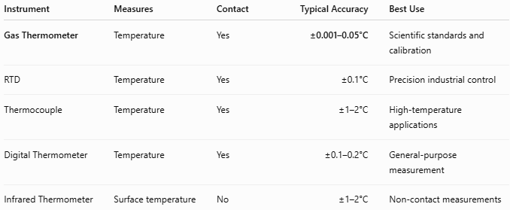
Instrument | Measures | Contact | Typical Accuracy | Best Use
Gas Thermometer | Temperature | Yes | ±0.001–0.05°C | Scientific standards and calibration
RTD | Temperature | Yes | ±0.1°C | Precision industrial control
Thermocouple | Temperature | Yes | ±1–2°C | High-temperature applications
Digital Thermometer | Temperature | Yes | ±0.1–0.2°C | General-purpose measurement
Infrared Thermometer | Surface temperature | No | ±1–2°C | Non-contact measurements

Care and Maintenance
# Source: AI Source: Provided by: [Data Path: Persons Table -> ID Column: 1, Name_En Column: Motasem Essam] -> From: [ChatGPT] on [7/17/2026]
To maintain accuracy:
- Prevent gas leakage.
- Keep the bulb clean.
- Handle with care.
- Calibrate periodically.
- Store in a controlled environment.

Common Mistakes
# Source: AI Source: Provided by: [Data Path: Persons Table -> ID Column: 1, Name_En Column: Motasem Essam] -> From: [ChatGPT] on [7/17/2026]
- Reading before equilibrium.
- Using contaminated gas.
- Ignoring pressure corrections.
- Improper calibration.

Key Points
# Source: AI Source: Provided by: [Data Path: Persons Table -> ID Column: 1, Name_En Column: Motasem Essam] -> From: [ChatGPT] on [7/17/2026]
- A Gas Thermometer measures temperature using the relationship between pressure, volume, and temperature of a gas.
- Common types include:
  - Constant-Volume Gas Thermometer
  - Constant-Pressure Gas Thermometer
  - Gas Bulb Thermometer
- Common units:
  - °C
  - K
  - °F

Conclusion
# Source: AI Source: Provided by: [Data Path: Persons Table -> ID Column: 1, Name_En Column: Motasem Essam] -> From: [ChatGPT] on [7/17/2026]
A Gas Thermometer is one of the most accurate temperature-measuring instruments available. By utilizing the predictable relationship between pressure, volume, and temperature of a gas, it serves as a primary reference thermometer for calibration and scientific research. Although it is more complex and less portable than other thermometers, its exceptional accuracy makes it indispensable in metrology, thermodynamics, and precision laboratory measurements.

